Unit 20. Licensing Overview
What This Unit Is About
This unit is an overview of iFOR/LS.
What You Should Be Able To Do
After completing this unit, students should be able to:
- Identify the basic concepts of licensing
- Define license enabled products
- Identify the components of iFOR/LS
- Set up and maintain BOS license requests
How You Will Check Your Progress
Accountability:
- Checkpoint questions
- Exercises
References
- IFOR/LS System Management Guide - SC23-2665
- IFOF/LS Tips and Techniques - SC23-2666

20.1 Objectives
After completing this unit, students should be able to:
- Identify the basic concepts of licensing
- Define license enabled products
- Identify the components of iFOR/LS
- Set up and maintain BOS license requests
Notes:

20.2 General Concepts
What is software licensing?
- Ability to control the number of users of a product on a machine or across multiple machines in a network
How is this achieved in AIX Version 4?
- iFOR/LS (information For Operation and Retrieval License System)

Notes:
- iFOR/LS is a software license management application for flexible network wide license sharing. iFOR/LS uses Network Computing System (NCS) distributed computing technology, the industry standard for remote procedure call, within a client/server model.
- AIX Licensed Program Products (LPPS) are sold and priced using 2 basic models:
- per user
- unlimited users / designated machine
- The intent is to provide customers with the ability to audit software usage on their systems and to provide a mechanism with which they can comply with their contracts with IBM. Through the use of encrypted keys, iFOR/LS can monitor the type and number of licenses used by a stand alone machine, or by machines within a network. In turn, the company can better ensure its own compliance with the terms of licensing agreements.
- Licensing is required to comply with the standards and also for support for software distribution on the CD-ROM.

20.3 iFOR/LS
- Components of iFOR/LS:
NCS 1.5.1
ARK
ADK

Notes:
- iFOR/LS is a superset of NetLS capabilities and the iFOR/LS commands are 100% compatible with NetLS. Hewlett Packard (HP) acquired NetLS from Apollo Computer, Inc, in 1987. Gradient Technologies, through an agreement with HP, ported NetLS to AIX and is currently enhancing the product which they have marketed under the name of iFOR/LS. iFOR/LS is available both from IBM and Gradient. The IBM Toronto lab first began using NetLS as a licensing tool for their products in July 1993 (prior to AIX Version 4).
- iFOR/LS requires NCS 1.5.1 (Network Computing System). NCS is a separately installed package, bosnet.ncs.obj, containing a set of tools for distributed computing.. NCS provides location information for license servers.
- ARK consists of management tools and report tools. The tools provide the capability to manage licenses in the network, as well as information about software and license usage in the network. The license server, used to maintain and grant licenses, and the license administration tool, used to insert licenses into the license server, are complemented by reporting tools, allowing a network administrator to monitor and report on the usage of applications across the network. These reports can then be used to track software, charge departments based on usage, and justify additional licenses and machines.
- iFOR/LS is divided into two parts to support both application developers and end users. Application developers need the Application Developer's Kit (ADK) to enable their applications; system administrators use the Administrator Runtime Kit (ARK) to install and maintain the license server, the location broker system, and the licenses.

20.4 AIX Version 4 BOS Product Offerings
AIX Client
AIX Server
All models
1-2 Users only
Desktop/Mini-
Tower
Entry Server
1-2 Users
Unlimited
(chlicense)
Deskside/Rack
Advance Server
1-2 Users
>2 User Options
Incremental
designated
machine(max.80)
(chlicense)
Floating
(iFOR/LS key)

Notes:
- The following AIX Version 4 BOS licenses can be obtained:
- Default 2-user licenses distributed with the software
By default 2 non-root users are allowed to login to the system. The root user does not consume any AIX Version 4 BOS licenses and is allowed unlimited logins.
- Additional fixed login licenses in increments of 1 for a designated machine (referred to as fixed licenses because they are available only on a specific machine). The number of fixed licenses can vary from 2 - 32767. The chlicense command or SMIT can be used to configure the system for these additional licenses.
- Additional floating user licenses in increments of 1 with no limit on the maximum value. These licenses are not restricted to a designated machine, and the right to use them is allowed to float in the network. The floating license option can be configured in addition to any fixed license already configured. Floating licenses are accessed by a request to a license server.
- Client Package
- Only offered as a 1 - 2 user product
- Server Packages - split for the different processor groupings
- Server Package - for example: 2xx. 3xx, 4xx and Cl0 systems
- Advanced Server Package - for example: 5xx and 9xx systems
- For the Entry Server, customers can purchase:

- 1 - 2 user license
- Unlimited license - customer will have to use the chlicense command to activate more than two users on the system
- For the Advanced Server, customers can purchase:
- 1 - 2 user license
- Additional licenses added in increments of 1 for a designated machine using the chlicense command. A basic AIX license can be expanded to include from 3 to 80 additional users, where 80 is a cap beyond which additional user licenses are not required for subsequent logins.
- Additional “floating” login licenses in increments of 1 with no cap. These licenses are not “fixed” to a designated machine and the right to use them is allowed to float in the network.
- Note that IBM does not force you to buy license keys for the operating system. As a system administrator you can specify how many you require. However, for products that are license enabled, you must contact the vendor in order to obtain the keys.

20.5 License-Enabled AIX Products
The following is a list of AIX Products which use licensing:
- XL Compilers
- Power Bench C++
- Workbench
- DB2
- CMVC
Notes:

20.6 iFOR/LS and AIX Version 4 BOS
AIX
login

iFOR/LS
NCS
RLM
DB2
C++
XLF
XLP
Work
bench
CATIA
AIX

Notes:
- RLM is Resource License Manager and is used by applications such as CATIA. RLM uses NCS 1.1 while iFOR/LS uses NCS 1.5.1. iFOR/LS can coexist in the same network partition as RLM. RLM-licensed client applications can also have their license requests satisfied by the iFOR/LS server.

20.7 Software Requirements

20.7.1 AIX Version 4 software requirements:
- AIX base operating system runtime (bos.rte)
- AIXwindows runtime environment (X11.base) (optional)
- TCP/IP client package (bos.net.tcp.client)
- TCP/IP SMIT support (bos.net.tcp.smit)

20.7.2 iFOR/LS requirements:
- bos.ifor_ls package which includes the following filesets:
bos.ifor_ls.client.rte
bos.ifor_ls.client.utils
bos.ifor_ls.server
- bos.net package which includes the following fileset:
bos.net.ncs
Notes:
- AIX Version 4 software requirements
- You must have installed the AIX BOS runtime (bos.rte)
- Install the AIX windows runtime environment (X11.base) if the iFOR/LS graphical user interface administration tools should be used. This is not required for use of iFOR/LS.
- The TCP/IP client package (bos.net.tcp.client) must be installed
- Optionally, you may install TCP/IP SMIT support (bos.net.tcp.smit)
- iFOR.LS Filesets: Packaging and Requirements
- Starting with AIX Version 4, the iFOR/LS related software is distributed in four filesets contained in two packages. Each of the filesets is separately installable and deinstallable.
- The following table shows the filesets and their sizes:

Package
Fileset
Size (MB)
bos.ifor_ls
bos.net
Total 4.3
bos.ifor_ls.client.rte
bos.ifor_ls.client.utils
bos.ifor_ls.server
0.9
1.2
0.5
bos.net.ncs
1.7

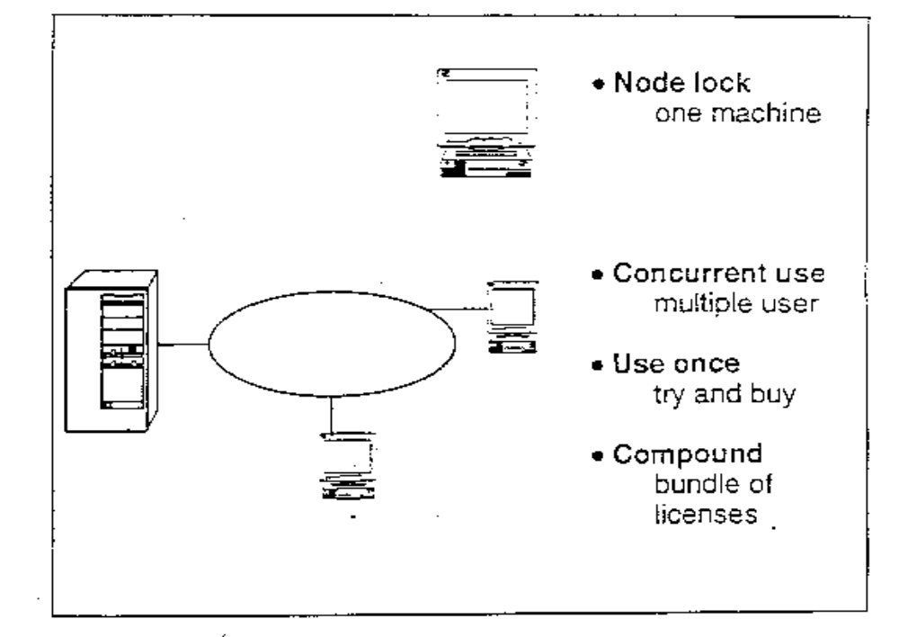20.8 License Types

Notes:
- iFOR/LS is capable of using a number of different types of licenses. The common types that we will see with AIX are Nodelock, Concurrent Use (floating), Use Once and Compound.
- Nodelock:
- Nodelock is a licensing mechanism that requires each workstation on which the licensed product operates to have its own unique key. When the client is invoked, the licensing mechanism runs in the local workstation's memory and thus checks the local workstation's target ID. Note that this implies nothing about where the software is installed. For example, an iFOR/LS client which is nodelocked may be run via some NFS mount. When the client is invoked, it will run in the local workstation's memory and thus check the local workstation's planar ID. If the NFS server has a nodelock key, it cannot be used to satisfy the license request made by the NFS client because the local planar ID is checked.

- Concurrent Use:
- The concurrent use licensing mechanism provides the right to use the software to “float” in the network. One or more license servers contain keys which satisfy license requests from software applications.
- Use Once:
- The use once mechanism is a consumable form of license. Unlike concurrent use, where a license is returned to the pool, a use once license cannot be reused. In iFOR/LS, a use once license for a particular product contains a count that is determined each time a license is used. When this value reaches zero, the license cannot be used for additional requests. Use once licenses cannot be deleted from the license database.
- Compound:
- A compound license contains a password that allows the creation of more licenses. The primary advantage of a compound license is its flexibility for redistributing licenses at a later date.

20.9 License Servers
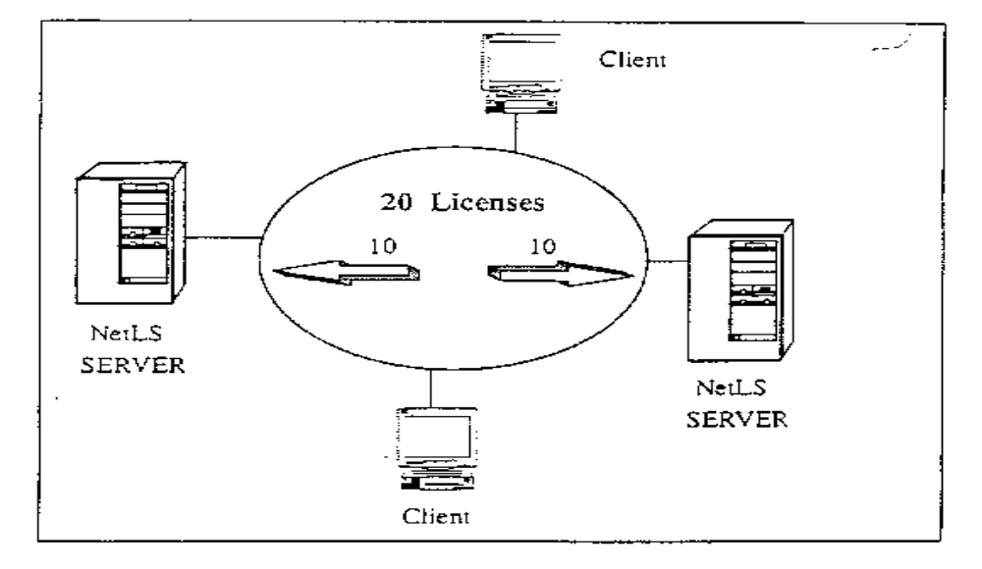
Notes:
- A license server should run on a system that is highly available, reliable, and in a controlled environment. Computers that are frequently unavailable, unreliable, unmanaged or shut down frequently for testing or maintenance are not good candidates. Ideally, license servers should be on the same LAN as the majority of the computers requesting licenses.
- Since each license server operates independently, administrators can partition licenses among multiple servers. For example, if two products have ten licenses each, an administrator may choose to install all twenty licenses on one server for easy administration. Alternatively, the administrator can configure 2 servers with 10 licenses for each product on each server to balance requests.

20.10 License Server Operation
product Request for
invoked License

License Request
Granted Approved

User file License database

Users

Software Product
(iFOR/LS enabled)

Calls to the License Server

License
Server
User
Access
rights
Vendor
Products
Licenses

Notes:
- The following is a summary of the sequence of events when a license server is utilized:
- A user invokes the product that has licensing enabled.
- The product requests a license from a license server.
- The license server checks the license database to see if a valid license is available and the user file to see if the user is allowed to use the product.
- If a license is available and the user is allowed to use the product, the server approves the request, or if there is a problem, it is written to the log file.
- When the user receives a license from the server, the product begins execution.
- When the user exits the program, the product releases the license back to the license server.

20.11 Licensing Policies
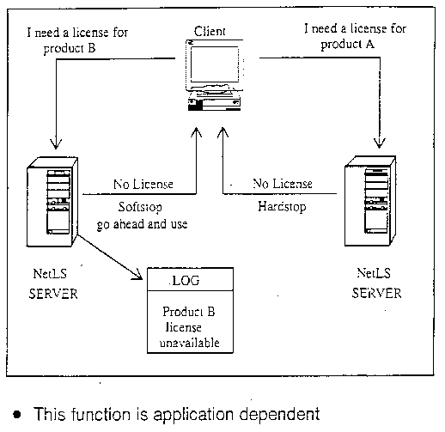

Notes:
- When a license is unavailable, there are two different policies that can be implemented:
- Softstop - allow the software to run without a license but post a message to the log
- Hardstop - do not allow the software to run when a license is unavailable
- The license types in iFOR/LS do not ENFORCE these policies. Developers must build in softstop or hardstop logic. If a license is unavailable, then queuing of the request may also be built into the application and supported by iFOR/LS.
- AIX Version 4 BOS login utilizes a hardstop policy.

20.12 Queuing
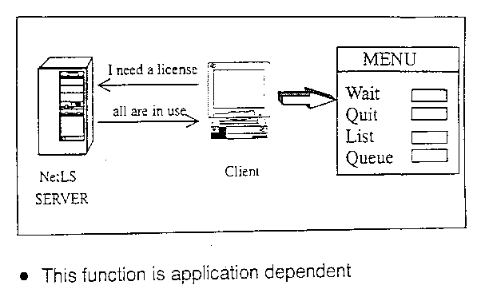

Notes:
- If an application (also known as a client) requests a license (or a key) and none are available, then it may offer the user the option to wait in a queue until a license becomes available. This is most commonly used for interactive applications.
- An ASCII menu is provided as part of the common code that is available to ADK users which offers the user the option to :
- Wait for the next license
- Quit the application
- List the machines currently using a license
- Queue displays your position in the queue

20.13 License Retention Period
- Specified by the application
- Passed to the iFOR/LS server daemon at application start-up
- What heart beat should be used for the check period?
- Long interval periods minimize network traffic
- Short interval periods speed up license down time recovery
- Recommended: 5 - 10 minutes
- Default: 15 minutes
- AIX Version 4 BOS login - 15 minutes

Notes:
- The heartbeat is another name for the check period. This is the time interval between checkpoints from the application to the server. If the application fails to contact the server for the heartbeat, then the application can hardstop (terminate) or softstop (continue). When communication is broken, the server retrieves licenses after the check period expires.
- The check period is specified by the application and can be hardcoded or configurable.
- At application start-up time, the application communicates with the iFOR/LS server daemon which heartbeat time-out period to use.
- What time period should be used for the check period ?
- Short intervals result in heavier network traffic
- Long intervals force longer recovery periods
- Default value is 15 minutes
- Configurable in 1 minute intervals

20.14 Daemons

20.14.1 llbd (NCS)
Implements the local location broker daemon

20.14.2 glbd (NCS)
Implements the global location broker daemon

20.14.3 netlsd (iFOR/LS)
Invokes the network license server daemon

20.14.4monitord (AIX)
Communicates with the iFOR/LS server to request a license per login

Notes:
1. llbd
- The llbd manages the local location broker database, which stores information about NCS-based server programs running on the local host. A host must run the llbd daemon to support the location broker forwarding function or to allow remote access to the local location broker database. In general, any host that runs an NCS-based server program should run an llbd daemon, and the llbd should be running before any such servers are started.
2. glbd
- The glbd manages the global location broker (GLB) database. The global location broker database helps clients to locate servers on a network. The GLB database stores the locations (specifically the network addresses and port numbers) of servers on which processes are running. The glbd daemon maintains this database and provides access to it.
- You can replicate the GLB database to increase its availability. Copies of the database can exist on several hosts, with glbd running on each of these hosts to maintain the consistency of the database replicas. Each replica of the GLB keeps a list of all the other GLB replicas.
3. netlsd
- Starts an iFOR/LS license server on the local node. At start-up, netlsd requests one free TCP/IP port. This port is dynamically assigned and the number is greater than 1024. netlsd then sends this information to the glbd.

- It is not mandatory that netlsd and glbd run on the same machine.

4. monitord
- AIX Version 4 SOS has multiple ways to access the system, and each of them has a different behavior upon exit. The monitord daemon provides a common interface to the iFOR/LS netlsd, monitord communicates with the iFOR/LS server and requests a concurrent-use license for each countable login. After a user logs off, monitord requests netlsd to release the specific license that the user was using in order to make it available for further logins, monitord is used only if the system has the floating license mode enabled.

20.15 Interaction of iFOR/LS and NCS
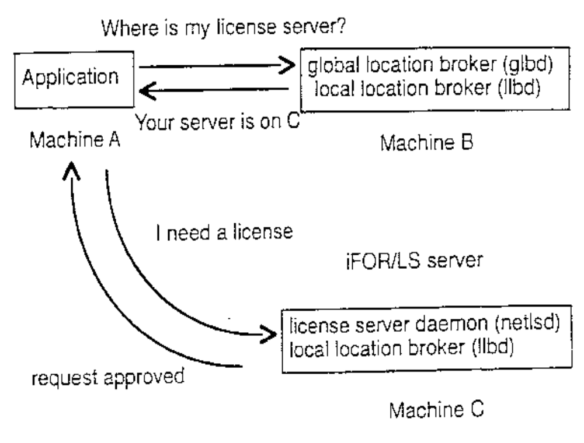
Notes:
Machine A is the client. It requests information about the location of the license server by contacting Machine B, which is running the glbd and llbd daemons. Machine B tells Machine A that its iFOR/LS server is Machine C, which is running the netlsd daemon. Machine A then contacts Machine C asking for a license. Approval is sent back from Machine C to Machine A.

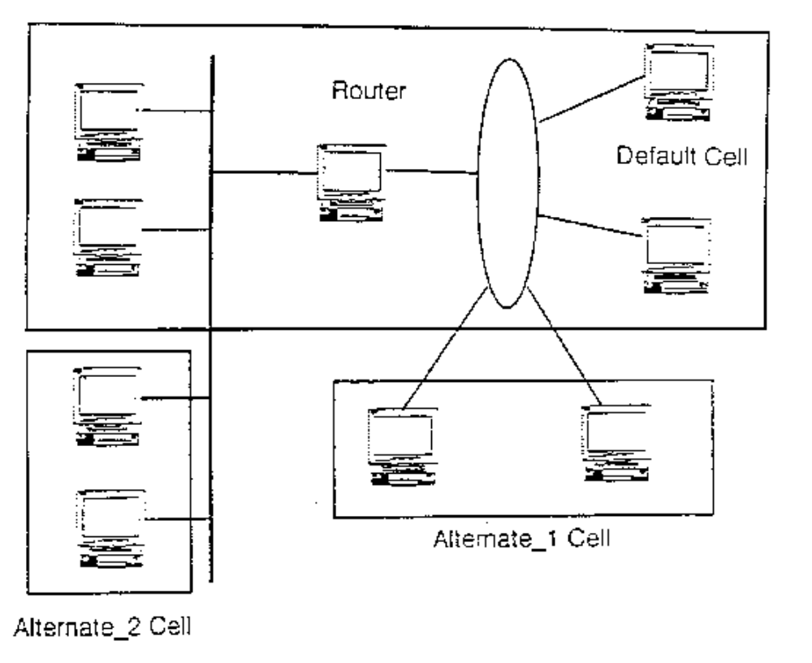20.16 What is an NCS Cell?
Notes:
- Sometimes it is desirable to logically partition a network so that some of the server only serve some of the clients. This grouping of clients and servers is known as a cell. A user application that requires a license will only be able to have is license request satisfied by a license server in the same cell.
- In a large network with more than one subnet, the broadcast from the client application may not reach the host where the global location broker is running. If this happens, the client machine can be configured to specifically direct the NCS request to the global location broker host machine.
- Examples of how you might want to partition your network and divide resources using NCS calls:
- a software development group
- a department
- a division of a company

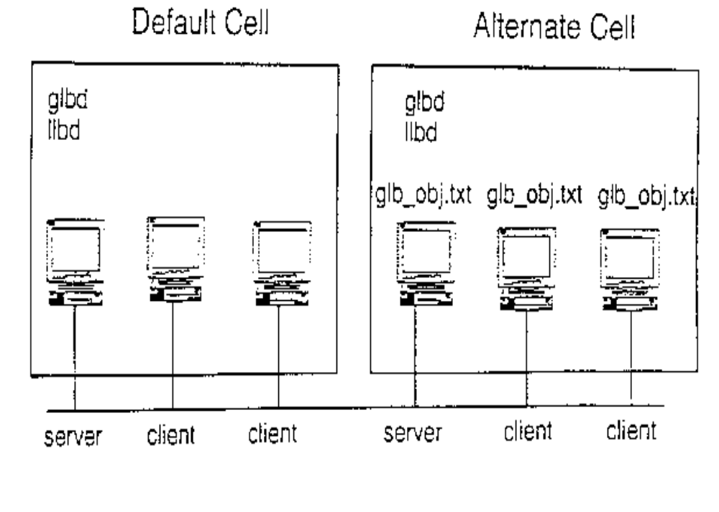20.17 NCS Cell Example - 2 Cells in Same Network

Notes:
- All the servers must run glbd and llbd daemons.
- On the clients, none of the NCS daemons are required.
- In the default cell, it is not mandatory to have the glb_obj.txt file. The UUID of the default cell is known.
- In the alternate cell, you must have the glb_obj.txt file containing the cell identifier to contact the server.

20.18 Change the Number of Licenses
# smit change_float
Notes:
Change the Number of Installed Floating User Licenses

Type or select values in entry fields.
Press Enter AFTER making all desired changes.

[Entry Fields]
*AIX User License to Change +
* New Number of Licenses []

F1=Help F2=Refresh F3=Cancel F4=List
F5=Reset F6=Command F7=Edit F8=Image
F9=Shell F10=Exit Enter=Do

- The chlicense command is applicable to AIX BOS licenses, not other products
- The syntax of the command is as follows
chlicense -u licenses -f on ︱off
- Flags:
-u changes the number of fixed licenses
-f changes the status of the floating license
You must reboot the system to make the new number of fixed user licenses effective.
You may also use the lslicense command to query the number of licenses.
chlicense -f on performs the following steps:
- Creates the following entry in /etc/inittab
monitord:2:once:lusr/sbin/monitord > /dev/console 2>&l
- Automatically starts the monitord using /usr/sbin/monitord -t 15
- Creates /etc/security/.netls
chlicense -f off performs the following steps:
- Removes /etc/security/.netls file if present
- Removes the /etc/inittab line for the monitord daemon
Examples:
- To set the number of fixed users to 25 enter
# chlicense -u 25
- To enable floating licenses enter
# chlicense -f on

20.19 monitord Activities
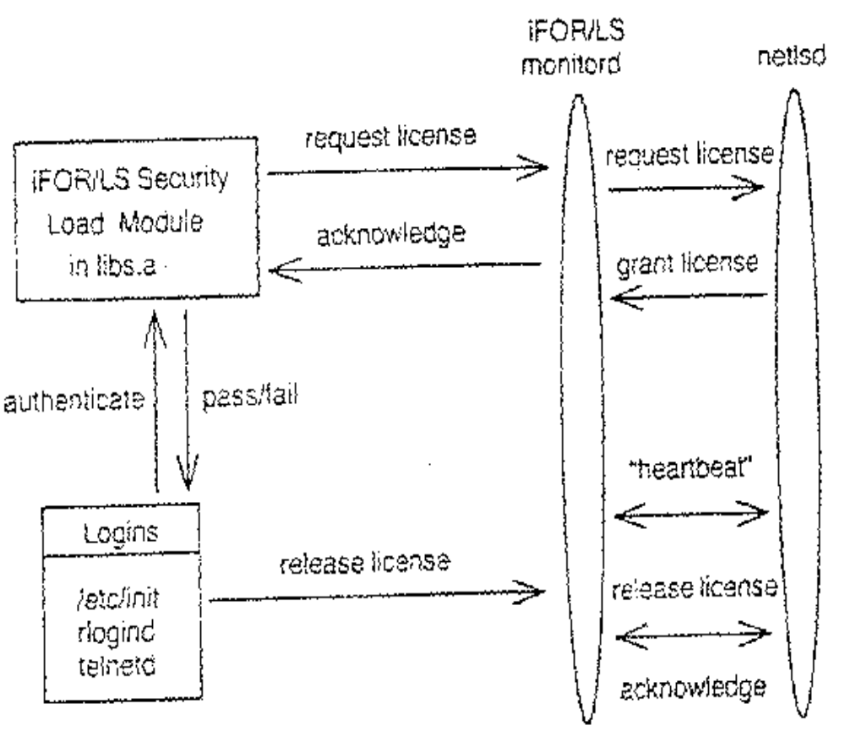Notes:
- monitord will be executed as a daemon upon system start-up via an entry in/etc/inittab (using a “boot” keyword) or by issuing the chlicense -fon command. It will run continuously, stopping only for a shutdown or single-user mode operation (maintenance mode). The monitord daemon will communicate with the NetLS security load module and with the login subsystems via a named pipe, set to appropriate privilege, and signals.
- The monitord daemon will appear to the iFOR/LS environment as an enabled application. It will be linked with the iFOR/LS library and perform all the communications between the running BOS and the netlsd, performing the actual token request, release and heartbeat operations.
- monitord keeps track of floating licenses.

20.20 AIX Version 4 BOS Fixed License Scenario
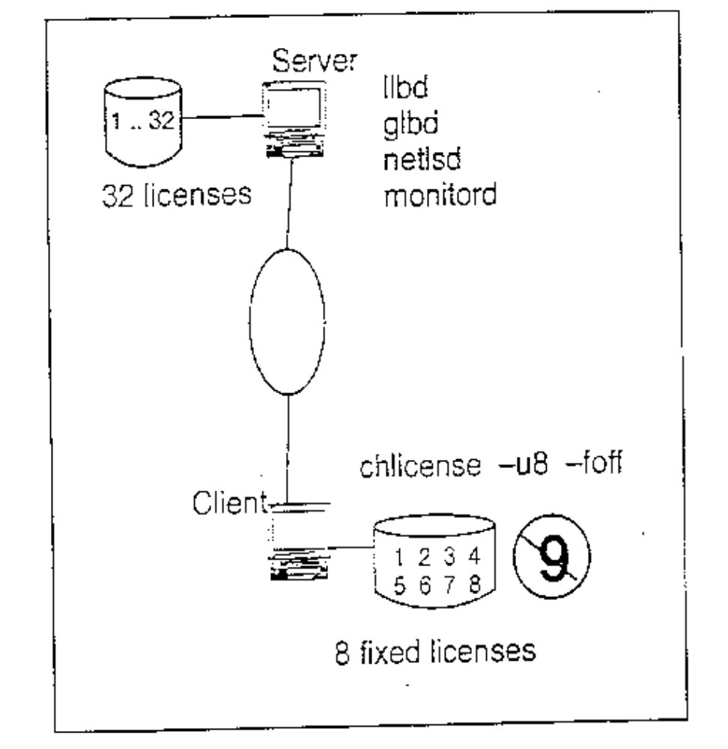
Notes:
- In this example, both machines are on the same network. The client system is configured for 8 fixed licenses and floating license mode is disabled (chlicense –u8 –foff). The iFOR/LS server has been configured with 32 floating licenses to grant AIX Version 4 BOS license requests from other machines in its network.
- When the 9the user attempts to login to the client system, the user receives a message that all login sessions are in use and the login attempt fails.

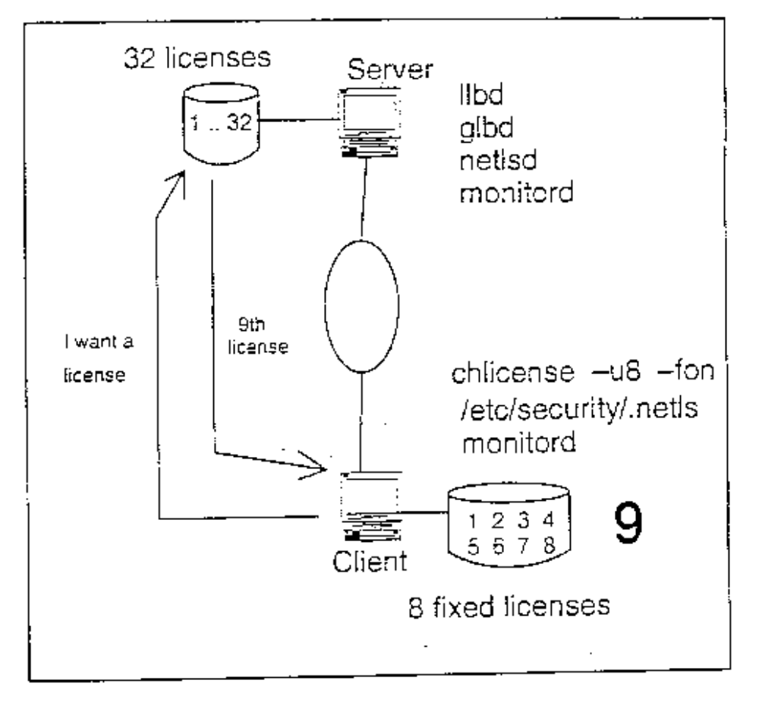20.21 AIX Version 4 BOS Floating License Scenario
Notes:
- In this example, both machines are on the same network. The client system is configured for 8 fixed licenses and floating license mode is enabled (chlicense -u8 -fon). The iFOR/LS server system has been configured with 32 floating licenses to grant AIX Version 4 BOS license requests from other machines in its network.
- When the 9th user attempts to login to the client system, the client system checks the number of logins and recognizes it has exhausted its number of fixed licenses. Since floating license mode is enabled, it sends a broadcast out to the network requesting the location of an iFOR/LS server that has AIX Version 4 BOS licenses available. The iFOR/LS server system hears the request, checks the number of available AIX Version 4 BOS floating licenses, and grants the license key request to the client system.

20.22 AIX Version 4 Floating License Server Setup

20.22.1 Install iFOR/LS software

20.22.2 Configure iFOR/LS and NCS

20.22.3 Start the server daemons:
- －llbd
- －glbd
- －netlsd

Notes:
- Setting up the iFOR/LS “floating” license server is a three step procedure:
- Install the iFOR/LS software
- Configure NCS and iFOR/LS
- Start the server daemons
- The installation process installs a shell script called netls_config in the directory /usr/lib/netls/conf. It gathers configuration information and creates another shell script called netls_first_time, also in the directory /usr/lib/netls/conf.

20.23 Configuring AIX BOS License Requests
Software License Management
Move cursor to desired item and press Enter.

Manage Nodelocked Licenses

Show Available License Servers
Show License Usage on Servers
Show Target ID

F1=Help F2=Refresh F3=Cancel F8=Image
F9=Shell F10=Exit Enter=Do

Manage License Server and License database
Notes:
Manage License Servers and License Database
Move cursor to desired item and press Enter.

Show Server Characteristics
Manage Concurrent Use and Use Once Licenses
Manage Vendor Information in the License Database

F1=Help F2=Refresh F3=Cancel F8=Image
F9=Shell F10=Exit Enter=Do

Perform Standalone Configuration for Adding /Using Licenses
- Performing stand alone configuration for adding using licenses
- This option will run the script /usr/lib/netls/conf/auto_config. This script will erase your current iFOR/LS network configuration and re-establish your machine as a stand alone server in an alternate NCS cell. Only applications that are started on this machine will be able to obtain licenses from the server on this machine. This option will:
- start the daemons - llbd, glbd and netlsd
- update the /etc/inittab file to automatically start your server when the system is rebooted
3. This option also enters the CPU ID of the configured machine.

20.24 iFOR/LS Administration Tools

20.24.1 /usr/lib/netls/bin/ls_tv
Verifies that the license servers are working. This tool will print a list of active license servers.

20.24.2 /usr/lib/netls/bin/ls_stat
Provides a graphical interface to status information on network licenses (that is all license types except nodelocks).

Notes:

20.25 Checkpoint
Exercise-Licensing Overview
- How many licenses does the AIX client package come with?
- What is the difference between nodelock and concurrent use licenses?
- Which command can be used to change the status of BOS floating licenses?

20.26 Unit Summary
- iFOR/LS is a software license management application for network-wide license sharing
- There are certain products available which are license-enabled
- The following components of iFOR/LS were considered:
- License types
- License server
- Licensing policies
- The chlicense command can be used to change the number of BOS licenses

